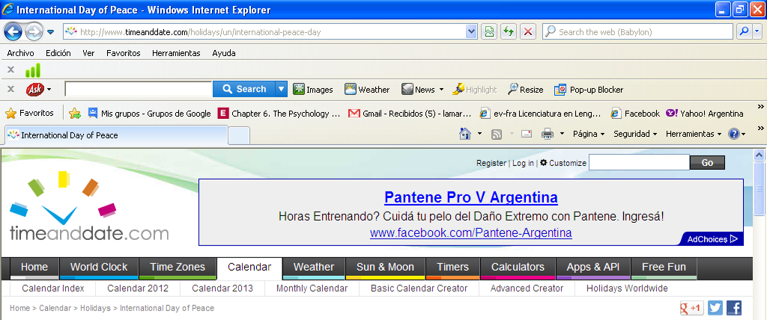
ACTIVIDAD 1 – Subrayar la/las palabras que marcan el contenido del sitio y el tema del texto

ACTIVIDAD 2 – Analizar la organización del texto y pasar a la actividad .

International Day of Peace

Quick Facts
The United Nations' (UN) International Day of Peace is annually held on September 21 to recognize the efforts of individuals, organizations and governments to end conflict and promote peace.

Local names
The dove is a symbol often associated with the International Day of Peace. ©iStockphoto.com/Sue McDonald
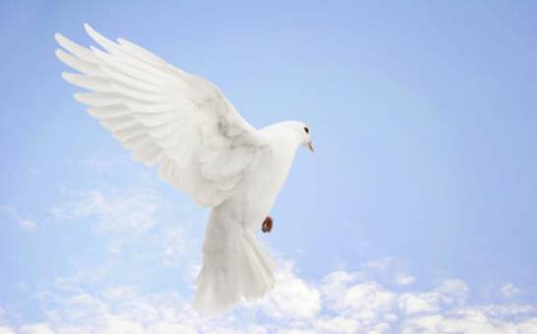
Name | Language
International Day of Peace | English
Día Internacional de la Paz | Spanish

Alternative name
Peace Day

International Day of Peace 2012
Friday, September 21, 2012

International Day of Peace 2013
Saturday, September 21, 2013
List of dates for other years

The United Nations' (UN) International Day of Peace is celebrated on September 21 each year to recognize the efforts of those who have worked hard to end conflict and promote peace. The International Day of Peace is also a day of ceasefire – personal or political.

What do people do?
On the International Day of Peace, also known as Peace Day, people around the world take part in various activities and organize events centered on the theme “peace”. Events vary from private gatherings to public concerts and forums involving large audiences. Activities include:
- Interfaith peace ceremonies.
- A toast for peace.
- A peace choir.
- Lighting candles.
- Peace prayers.
- A peace convoy of vehicles.
- Tree planting for peace.
- Art exhibitions promoting peace.
- Picnics for peace.
- Peace walks.
Organizations such as Roots & Shoots, an international environmental and humanitarian program for youth, show their support for the event on an annual basis. Young people involved in Roots & Shoots may engage in activities such as crafting giant peace dove puppets from re-used materials and flying the doves in their communities. People from diverse religious and spiritual backgrounds also commit to organizing an International Day of Peace Vigil. Some groups observe a minute of silence at noon in every time zone across the world on Peace Day.

Public life
The UN’s International Day of Peace is a global observance and not a public holiday. It is a day when nations around the world are invited to honor a cessation of hostilities during the day.

Background
A UN resolution established the International Day of Peace in 1981 to coincide with the opening of the UN General Assembly. The first Peace Day was celebrated in 1982 and was held on the third Tuesday of September each year until 2002, when September 21 became the permanent date for the International Day of Peace. The assembly decided in 2001 that the International Day of Peace should be annually observed on September 21 starting from 2002. By setting a fixed date for the International Day of Peace, the assembly declared that the day should be observed as a day of global ceasefire and non-violence.
By creating the International Day of Peace, the UN devoted itself to worldwide peace and encouraged people to work in cooperation for this goal. Since its inception, Peace Day has marked personal and planetary progress toward peace. It has grown to include millions of people worldwide and many events are organized each year to commemorate and celebrate this day.

Symbols
The peace dove flying with an olive branch in its beak is one of the most commonly featured symbols for the day. In Judaism, Christianity, and Islam a white dove is generally a sign for peace. The dove can also represent “hope for peace” or a peace offering from one person to another, hence the phrase “to extend an olive branch”. Often, the dove is represented as still in flight to remind people of its role as messenger.

ACTIVIDAD 3 – Colocar el título de la sección

- Tipo de celebración ……………………………………………………..
- Actividades ……………………………………………………..
- Símbolos ……………………………………………………..
- Historia ……………………………………………………..
- Referencia rápida ……………………………………………………..
(Buscar en este último ejemplo su correspondencia con los textos de Wikipedia en el TP 1)
ACTIVIDAD 4 –
- Subrayar el Tema (sujeto) de la primera oración en cada párrafo (atendiendo a la puntuación y referencias temporales)
- Completar lista con los temas de la primera oración en cada párrafo del texto
- ………………………… 5. …………………………..
- ………………………… 6. …………………………..
- ……………………… 7. ……………………………..
- ………………………

ACTIVIDAD 5 –
- Encerrar en un círculo la opción correcta
The United Nations' (UN) International Day of Peace is celebrated on September 21 each year to recognize the efforts of those who have worked hard to end conflict and promote peace. The International Day of Peace is also a day of ceasefire – personal or political.
La segunda oración:
- Continúa el mismo tema.
- Pasa a otro tema.
La palabra “also”, indica que después del “.”se – o se +
Las palabras subrayadas (palabras de contenido) expresan conceptos centrales o relaciones entre conceptos.
- Buscar en el primer párrafo (Quick Facts), la frase equivalente a “those who have worked hard”, y completar
……………………………………………………..……………………………………………………..
ACTIVIDAD 6 –
- Subrayar las palabras de contenido en esta primera oración de párrafo
On the International Day of Peace, also known as Peace Day, people around the world take part in various activities and organize events centered on the theme “peace”.
- Escribir en las líneas de puntos los temas (conceptos) que podrían desarrollarse en las siguientes
…………………………………………………….. ……………………………………………………..
- Releer el texto y confirmar o corregir.
- Encerrar en un círculo la opción correcta
- La oración (oración tópico) presenta la idea principal del párrafo. Si no
- Las otras oraciones presentan datos de apoyo a lo dicho. Si no
ACTIVIDAD 7 –
- Subrayar la oración tópico del siguiente párrafo
- Completar el siguiente concepto: Roots & Shoots es …………………………………………………
- Encerrar en un círculo la opción correcta. “Such as” es un conector que introduce
- Una conclusión
- Un ejemplo
- En “show their support for the event on an annual basis” la palabra “support” es
- Transparente
- Una falsa transparencia
- Seleccionar el significado apropiado para este contexto.

- Buscar en la primera oración el sustantivo relacionado con el adjetivo “young” en la segunda y completar.……………………………………………………..
- “Involved” es una falsa transparencia. Elegir el significado apropiado en este contexto.
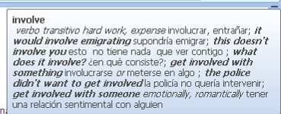
¿Cómo hubo que buscarlo?
- Buscar en las oraciones con datos de apoyo, el tema que se desarrolla en cada una y completar.
…………………………………………………….. ……………………………………………………..
- “such as” introduce ejemplos de:
ACTIVIDAD 8 – a. Encerrar en un círculo la opción correcta.
- Es un feriado. Si - No. (Subrayar las palabras que orientaron la respuesta.)
- La segunda oración fundamenta los dichos en la primera. Si - No.
The UN’s International Day of Peace is a global observance and not a public holiday. It is a day when nations around the world are invited to honor a cessation of hostilities during the day.
- “It” se refiere a ……………………………………………………..

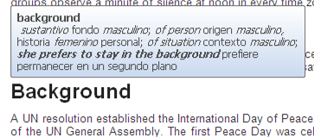

ACTIVIDAD 9 –
- Elegir el significado apropiado en este contexto.
- Buscar en “Background” las respuestas a las siguientes preguntas

- ¿Desde qué año celebra? …………………………
- ¿Cuándo pasó a una fecha fija? ……………………………………………………..
- ¿Cuál fue el objetivo perseguido? ¿Qué se propuso estimular? …………………………………………………
- ¿Qué significa en el presente? ……………………………………………………..
- Vocabulary
- Identificar la diferencia entre “was held” en este sector con “is annually held” al comienzo del texto.
¿Cómo habría que buscar el significado?
- Observar lo que ocurre al aplicar el traductor.
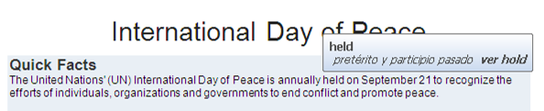
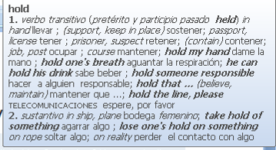
¿Cuál es el significado más apropiado?
- Encerrar en un círculo la opción correcta.
- En “Since its inception”, la referencia temporal indica: un período - un momento
- El significado más apropiado es: desde - hasta
ACTIVIDAD 10 – Encerrar en un círculo la imagen que representa el símbolo.

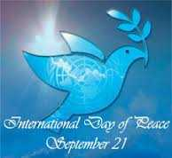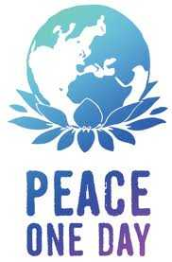
ACTIVIDAD 11 –
- Encerrar en un círculo la opción correcta.
- On the International Day of Peace, also known as Peace Day,
“…, also known as…,” ₌ o ≠ “…, also called …, “
- “the day should be observed as a day of global ceasefire and non-violence.”
“Should” expresa: posibilidad – obligación
- “Young people involved in Roots & Shoots may engage in activities”
“May” expresa: posibilidad – obligación
- on September 21 in 1981 in 1982
“In” se usa para fecha exacta Si - No.
- En “many events are organized each year to commemorate and celebrate this day”, subrayar la/s palabra/s con que se indica el propósito…………………………….
- ¿Qué se indica con “from … to”? ………………………………
Events vary from private gatherings to public concerts and forums

